1)

Code:

CREATE DATABASE w4q1_Bonk;

USE w4q1_Bonk;

CREATE TABLE branch (

branch_name VARCHAR(255) PRIMARY KEY,

branch_city VARCHAR (255) NOT NULL,

assets INT NOT NULL

);

INSERT INTO branch (branch_name, branch_city, assets) VALUES

("Brighton" , "Brooklyn" , 71E6),

("Downtown" , "Brooklyn" , 90E5),

("Mianus" , "Horseneck" , 4E5),

("North Town", "Rye" , 37E5),

("Perryridge", "Horseneck" , 17E5),

("Pownal" , "Bennington", 3E5),

("Redwood" , "Palo Alto" , 21E5),

("Round Hill", "Horseneck" , 80E5);

CREATE TABLE customer (

customer_name VARCHAR(255) PRIMARY KEY,

customer_street VARCHAR(255) NOT NULL,

customer_city VARCHAR(255) NOT NULL

);

INSERT INTO customer (customer_name, customer_street, customer_city) VALUES

("Adams" , "Spring" , "Pittsfield"),

("Brooks" , "Senator" , "Brooklyn" ),

("Curry" , "North" , "Rye" ),

("Glenn" , "Sand Hill", "Woodside" ),

("Green" , "Walnut" , "Stamford" ),

("Hayes" , "Main" , "Harrison" ),

("Johnson" , "Alma" , "Palo Alto" ),

("Jones" , "Main" , "Harrison" ),

("Lindsay" , "Park" , "Pittsfield"),

("Smith" , "North" , "Rye" ),

("Turner" , "Putnam" , "Stamford" ),

("Jackson" , "East" , "Downtown" ),

("Williams", "West" , "Downtown" );

-- Seems like `account` can be used as variable

-- and is not actually a keyword

CREATE TABLE accounts (

account_number VARCHAR(255) PRIMARY KEY,

branch_name VARCHAR(255) NOT NULL,

balance INT NOT NULL,

FOREIGN KEY (branch_name) REFERENCES branch(branch_name),

CHECK (account_number REGEXP '^A\-[1-9][0-9]*$')

);

INSERT INTO accounts (account_number, branch_name, balance) VALUES

("A-101", "Downtown" , 500),

("A-102", "Perryridge", 400),

("A-201", "Brighton" , 900),

("A-215", "Mianus" , 700),

("A-217", "Brighton" , 750),

("A-222", "Redwood" , 700),

("A-305", "Round Hill", 350);

CREATE TABLE loan (

loan_number VARCHAR(255) PRIMARY KEY,

branch_name VARCHAR(255) NOT NULL,

amount INT NOT NULL,

FOREIGN KEY (branch_name) REFERENCES branch(branch_name),

CHECK (loan_number REGEXP '^L\-\[1-9][0-9]*$')

);

INSERT INTO loan (loan_number, branch_name, amount) VALUES

("L-11", "Round Hill", 900),

("L-14", "Downtown" , 1500),

("L-15", "Perryridge", 1500),

("L-16", "Perryridge", 1300),

("L-17", "Downtown" , 1000),

("L-23", "Redwood" , 2000),

("L-93", "Mianus" , 500);

CREATE TABLE depositor(

customer_name VARCHAR(255) NOT NULL,

account_number VARCHAR(255) NOT NULL,

FOREIGN KEY (customer_name) REFERENCES customer(customer_name),

FOREIGN KEY (account_number) REFERENCES accounts(account_number)

);

INSERT INTO depositor (customer_name, account_number) VALUES

("Hayes" , "A-102"),

("Jackson", "A-101"),

("Johnson", "A-201"),

("Jones" , "A-217"),

("Lindsay", "A-222"),

("Smith" , "A-215"),

("Turner" , "A-305");

CREATE TABLE borrower(

loan_number VARCHAR(255) NOT NULL,

customer_name VARCHAR(255) NOT NULL,

FOREIGN KEY (loan_number) REFERENCES loan(loan_number),

FOREIGN KEY (customer_name) REFERENCES customer(customer_name)

);

INSERT INTO borrower (customer_name, loan_number) VALUES

("Adams" , "L-16"),

("Curry" , "L-93"),

("Hayes" , "L-15"),

("Jackson" , "L-14"),

("Jones" , "L-17"),

("Smith" , "L-11"),

("Smith" , "L-23"),

("Williams", "L-17");

DELETE FROM customers;

DROP TABLE depositor;

DROP DATABASE w4q1_bonk;

Inputs:

* Branch Table:

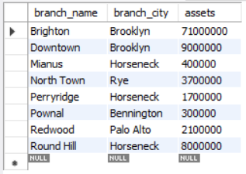

* Customer Table:

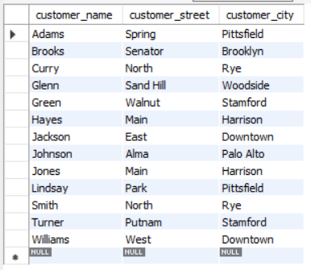

* Accounts Table:

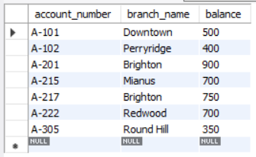

* Loan Table:

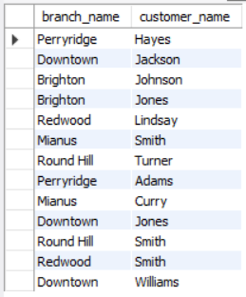

* Depositor Relation:

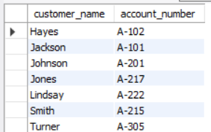

* Borrower Relation:

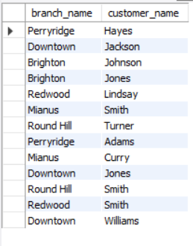

Queries & Outputs:

-- 1a) Create a view consisting of branch names and the names of customers who have either

-- an account or a loan at that branch. Assume that view to be called all-customer.

CREATE VIEW all_customer AS

SELECT branch_name, customer_name

FROM depositor, accounts

WHERE depositor.account_number = accounts.account_number

UNION

(SELECT branch_name , customer_name

FROM borrower , loan

WHERE borrower.loan_number = loan.loan_number);

-- For Output

SELECT * FROM all_customer;

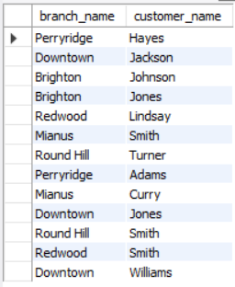

-- 1b) Create a view gives for each branch the sum of the amounts of all the loans at the branch

CREATE VIEW sum_of_loans AS

SELECT branch_name , SUM(amount)

FROM loan

GROUP BY branch_name;

-- For Output

SELECT * FROM sum_Of_Loans;

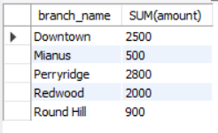

-- 1c) Using the view all-customer, we can find all customersof the Perryridgebranch

SELECT customer_name

FROM all_customer

WHERE branch_name = "Perryridge";

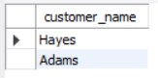

-- 1d Write a Query for below Relational algebraic notation :

SELECT depositor.customer_name

FROM depositor

UNION

(SELECT borrower.customer_name

FROM borrower);

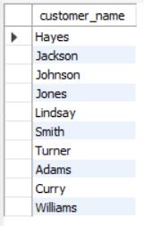

2)

Code:

CREATE DATABASE Sasalele;

USE sasalele;

CREATE TABLE Salesman (

salesman_id INT PRIMARY KEY,

sname VARCHAR(25) NOT NULL,

city VARCHAR(21) NOT NULL,

commission FLOAT(3,2) NOT NULL

);

INSERT INTO Salesman VALUES

(5001, 'James Hoog', 'New York', 0.15),

(5002, 'Nail Knite', 'Paris' , 0.13),

(5005, 'Pit Alex' , 'London' , 0.11),

(5006, 'Mc Lyon' , 'Paris' , 0.14),

(5007, 'Paul Adam' , 'Rome' , 0.13),

(5003, 'Lauson Hen', 'San Jose', 0.12);

CREATE TABLE Customer (

customer_id INT PRIMARY KEY,

cust_name VARCHAR(25) NOT NULL,

city VARCHAR(20) NOT NULL,

grade INT NOT NULL,

salesman_id INT,

FOREIGN KEY (salesman_id) REFERENCES salesman(salesman_id)

);

INSERT INTO Customer VALUES

(3002, 'Nick Rimando' , 'New York' , 100, 5001),

(3007, 'Brad Davis' , 'New York' , 200, 5001),

(3005, 'Graham Zusi' , 'Califonia', 200, 5002),

(3008, 'Julian Green' , 'London' , 300, 5002),

(3004, 'Fabian Johnson', 'Paris' , 300, 5006),

(3009, 'Geoff Cameron' , 'Berlin' , 100, 5003),

(3003, 'Jozy Altidor' , 'Moscow' , 200, 5007),

(3001, 'Brad Guzan' , 'London' , 300, 5005);

CREATE TABLE Orders (

ord_no INT PRIMARY KEY,

purch_amt FLOAT(6,2) NOT NULL,

ord_date DATE NOT NULL,

customer_id INT NOT NULL,

FOREIGN KEY (customer_id) REFERENCES customer(customer_id),

salesman_id INT NOT NULL,

FOREIGN KEY (salesman_id) REFERENCES salesman(salesman_id)

);

INSERT INTO Orders VALUES

(70001, 150.5 , '2012-10-05', 3005, 5002),

(70009, 270.65, '2012-09-10', 3001, 5005),

(70002, 65.26, '2012-10-05', 3002, 5001),

(70004, 110.5 , '2012-08-17', 3009, 5003),

(70007, 948.5 , '2012-09-10', 3005, 5002),

(70005, 2400.6 , '2012-07-27', 3007, 5001),

(70008, 5760 , '2012-09-10', 3002, 5001),

(70010, 1983.43, '2012-10-10', 3004, 5006),

(70003, 2480.4 , '2012-10-10', 3009, 5003),

(70012, 250.45, '2012-06-27', 3008, 5002),

(70011, 75.29, '2012-08-17', 3003, 5007),

(70013, 3045.6 , '2012-04-25', 3002, 5001);

DELETE FROM Orders;

DELETE FROM Customer;

DELETE FROM Salesman;

DROP TABLE Customer, Salesman, Orders;

DROP DATABASE Sasalele;

Inputs:

* Customer Table:

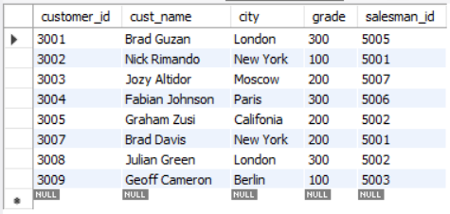

* Salesman Table:

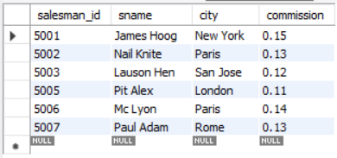

* Orders Relation:

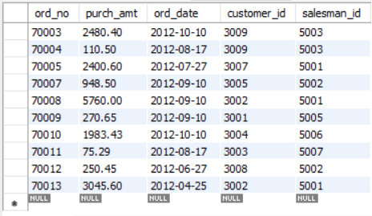

Queries & Outputs:

-- 2a) From the table, create a view to count the number of customers in each grade.

CREATE VIEW grade_count (grade, count)

AS SELECT grade, COUNT(*)

FROM customer

GROUP BY grade;

SELECT * from grade_count;

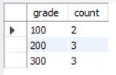

-- 2b) From the following table, create a view to count the number of unique

-- customer, compute average and total purchase amount of customer orders by

-- each date.

CREATE VIEW total_by_date

AS SELECT ord_date, COUNT(DISTINCT customer_id),

AVG(purch_amt), SUM(purch_amt)

FROM orders

GROUP BY ord_date;

SELECT * FROM total_by_date;

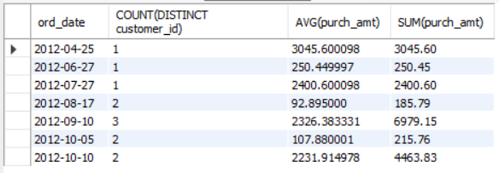

-- 2c) Create a view to get the salesperson and customer by name. Return order

-- name, purchase amount, salesperson ID, name, customer name.

CREATE VIEW order_details

AS SELECT ord_no, purch_amt, a.salesman_id, sname, cust_name

FROM orders a, customer b, salesman c

WHERE a.customer_id = b.customer_id

AND a.salesman_id = c.salesman_id;

SELECT * FROM order_details;

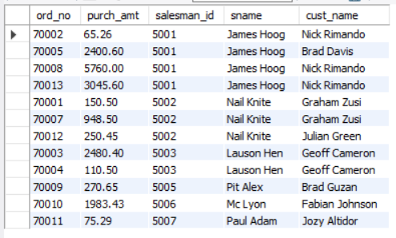

-- 2d) Create a view to find the salespersons who issued orders on October 10th,

-- 2012. Return all the fields of salesperson.

CREATE VIEW salesman_oct_10

AS SELECT *

FROM salesman

WHERE salesman_id IN

(SELECT salesman_id

FROM orders

WHERE ord_date = '2012-10-10');

SELECT * FROM salesman_oct_10;

